WACB Press

South West

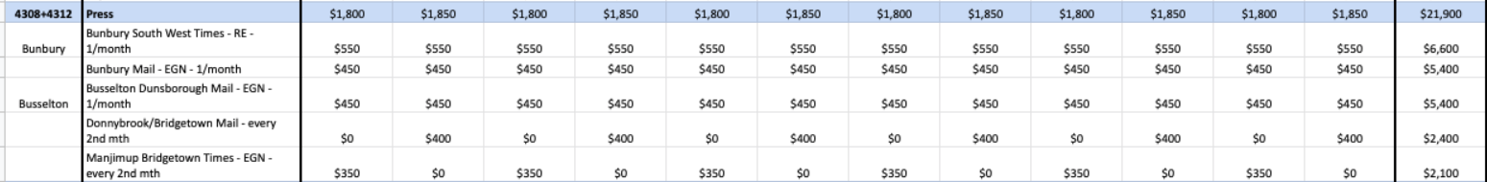

Avon

Great Southern

Mid West

RBC

South West

Avon

Great Southern

Mid West

SS

Great Southern

Mid West

